# Datasets

## Source – folder only

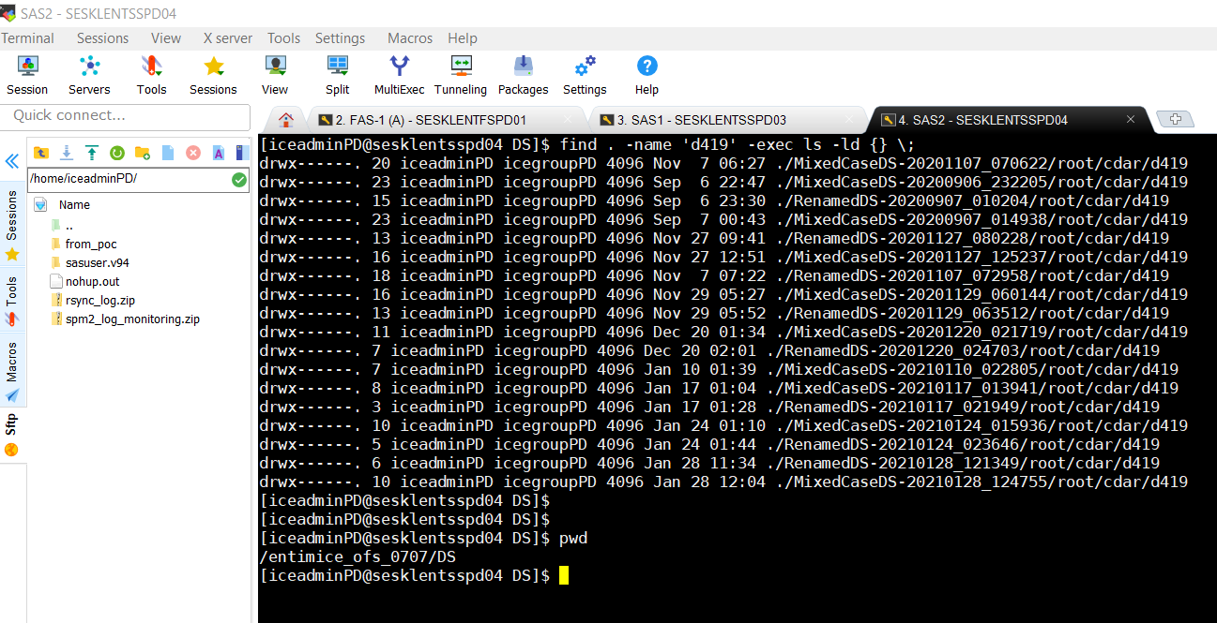

## Target – folder only

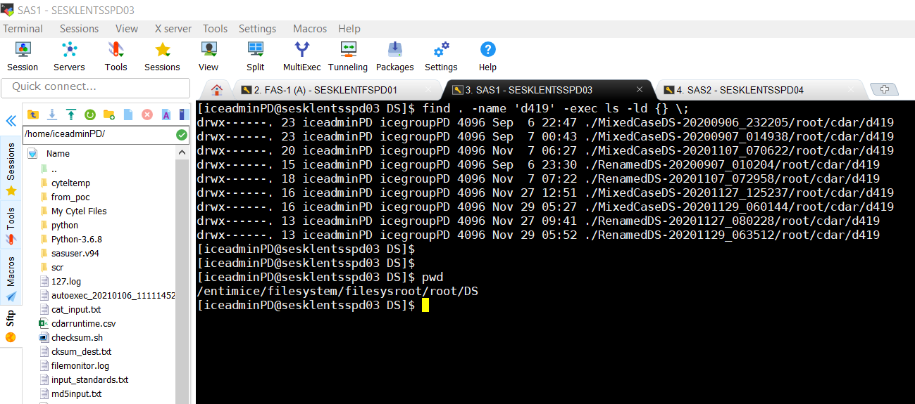

## Source & Target – CMDS

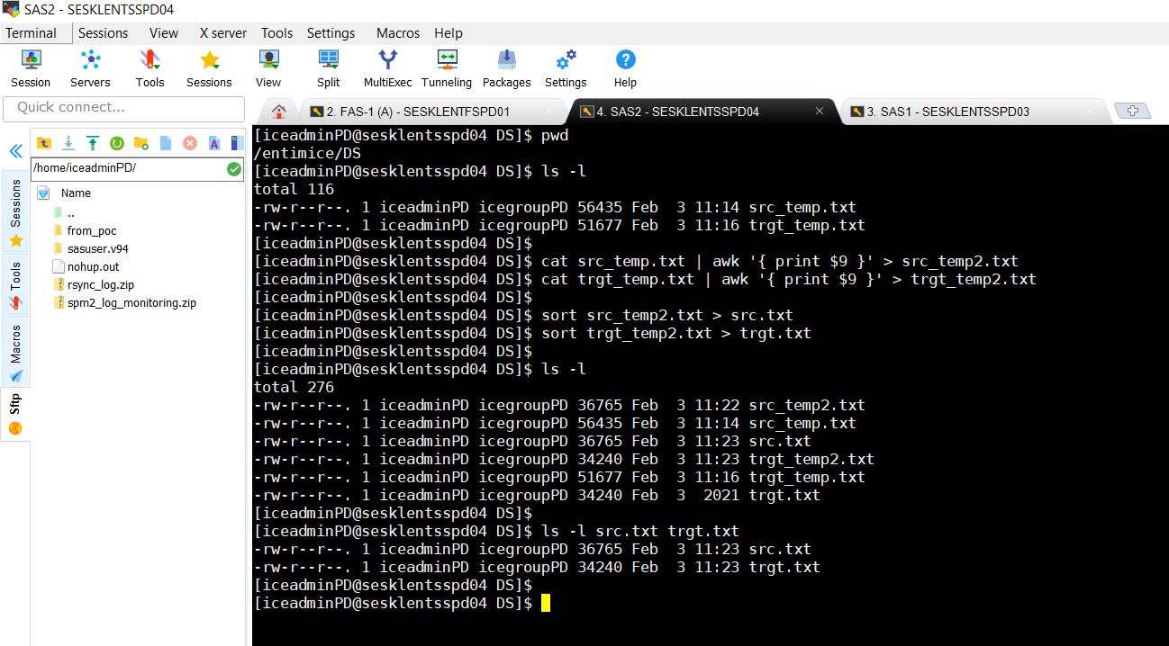

## Diff source & target

Only 2 datasets are missing

./RenamedDS-20201220_024703/root/cdar/d419/d419bc00001/ar/psc_china/restricted_raw/dev/data/data_area/d419bc00001_live_kit_data.sas7bdat

./RenamedDS-20210128_121349/root/cdar/d419/d419lc00001/ar/psc/restricted_RAW/prod/data/data_area/d419lc00001_live_kit_data.sas7bdat

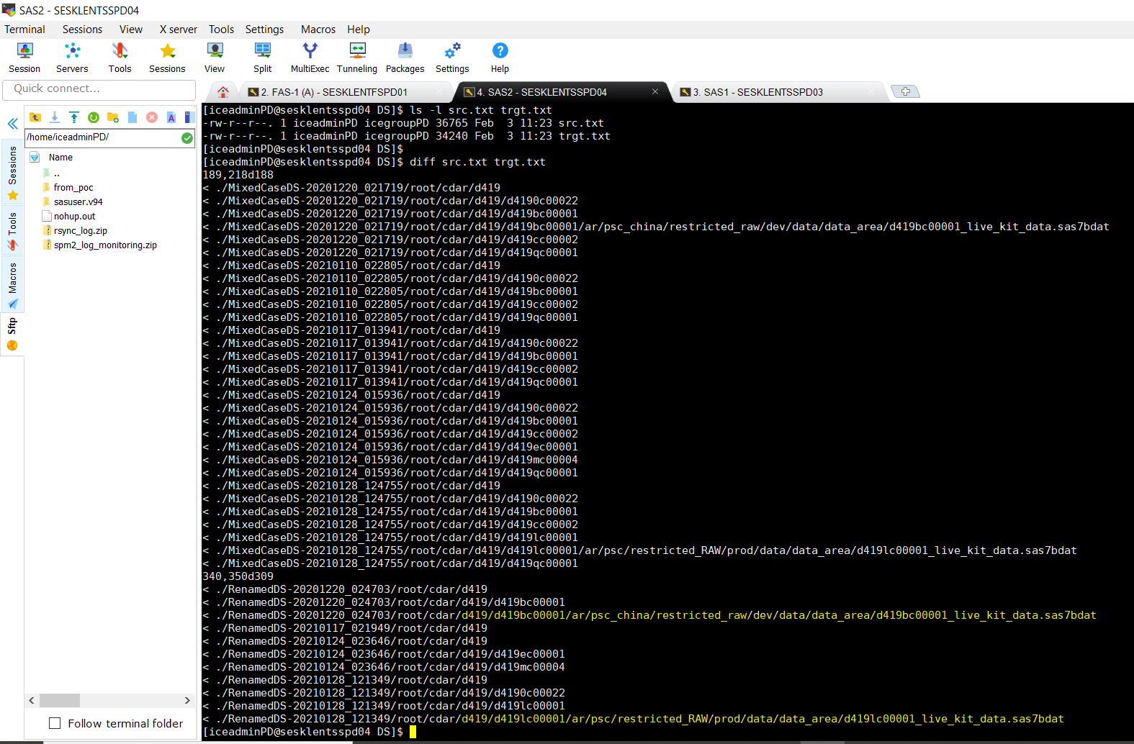

## Cross checking the missing datasets – LOGS

Only 2 datasets are missing

./RenamedDS-20210128_121349/root/cdar/d419/d419lc00001/ar/psc/restricted_RAW/prod/data/data_area/d419lc00001_live_kit_data.sas7bdat

./RenamedDS-20201220_024703/root/cdar/d419/d419bc00001/ar/psc_china/restricted_raw/dev/data/data_area/d419bc00001_live_kit_data.sas7bdat

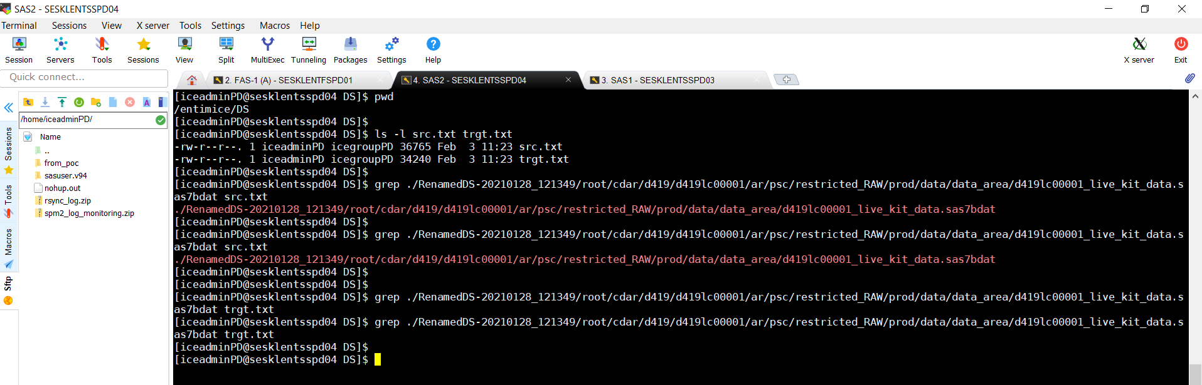

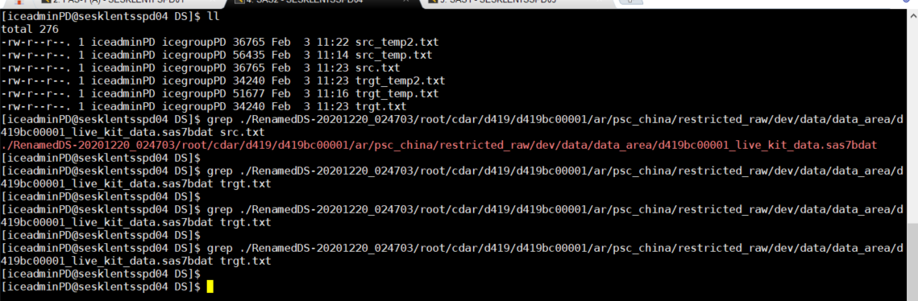

## Cross checking the missing datasets – 1 => No issues (DS already present and with small case & opening)

./RenamedDS-20201220_024703/root/cdar/d419/d419bc00001/ar/psc_china/restricted_raw/dev/data/data_area/d419bc00001_live_kit_data.sas7bdat

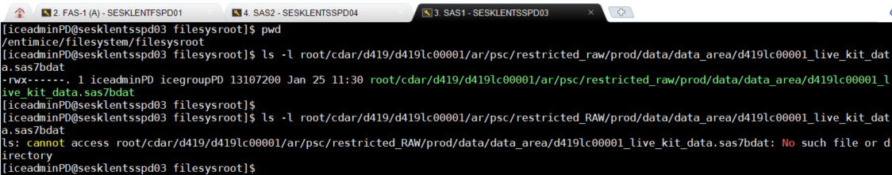

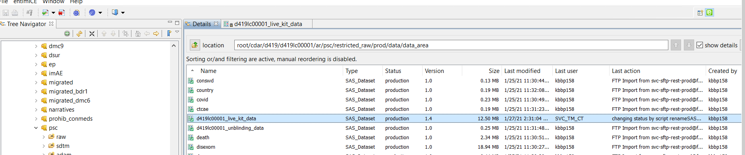

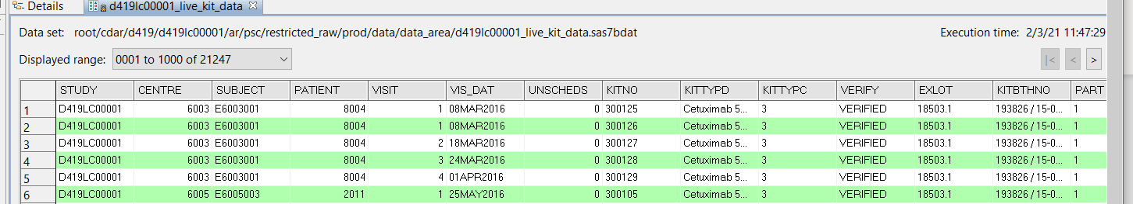

## Cross checking the missing datasets – 2 => No issues (DS already present and with small case & opening)

./RenamedDS-20201220_024703/root/cdar/d419/d419bc00001/ar/psc_china/restricted_raw/dev/data/data_area/d419bc00001_live_kit_data.sas7bdat



